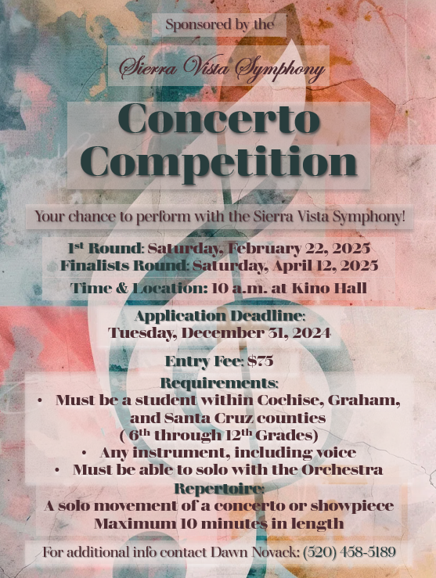

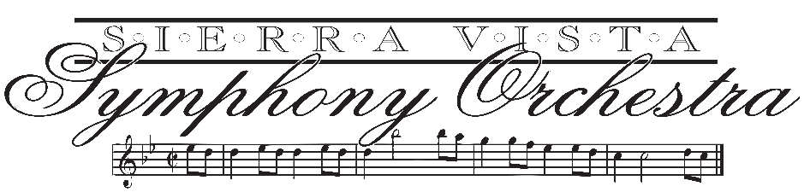

Dear Instructors and Students,

The Sierra Vista Symphony Association is excited to reintroduce our Annual Concerto Youth Competition. The winner of the competition will have an opportunity to perform with the Symphony at our Winter concert in January of 2026.

**Competition:** **First Round:**

Saturday, February 22nd **(Memorization not required)**

10:00 a.m.

Kino Hall

800 N. Taylor Drive, Sierra Vista, AZ 85635

**Second (Finalist) Round:**

Saturday, April 12th **(Memorization required)**

10:00 a.m.

Kino Hall

800 N. Taylor Drive, Sierra Vista, AZ 85635

**Performance:** January 2026

Klein Center for the Performing Arts

There is a $75 application fee to be received no later than December 31st, 2024. We accept both checks and CC payments through phone or in person during our normal office hours.

For more information visit the web at [www.sierravistasymphony.org](http://www.sierravistasymphony.org) If you have any questions, please contact me at (520) 458-5189.

Sincerely,

Dawn Novack

Office Manager

Sierra Vista Symphony Association

**Rules and Regulations**

* Applications must be received by no later than 6:00 p.m. on Friday, December 31st, 2024
* Applicants will still be enrolled in school for that current school year and not graduated from high school at the time of the audition.
* The student must be from Cochise, Santa Cruz, or Graham Counties.
* Applicants must provide 2 copies of music for judges.
* Winner will be asked to provide a photo in high resolution and bio for both the concert program and symphony brochure.
* First place winner may perform with the Sierra Vista Symphony for our Winter concert in January of 2026.
* The judges’ decisions are final.

**Repertoire Requirements**

* Repertoire: (a movement of a concerto, show piece)
* Music must be available for SVSA. (Private teacher is responsible for making sure the Orchestra parts are appropriate, and available to purchase, you may look at [imslp.org](http://imslp.org/) to see the instrumentation of the piece)
* If music needs to be rented, the winner and the winner’s teacher are responsible for the rental fee. (Music rental fees are often around $500)
* Any Instrument or Voice
* Maximum time length 10 minutes
* 2 copies of music must be available for the judges
* Music does not need to be memorized for initial round, but must be memorized by second (final) round

**Sierra Vista Symphony Association**

**Concerto Competition**

**Application**

**Contact Information**

Applicant’s Full Name: ______________________________________________

Date of Birth: ______/_____/_____ Grade in School:______________________

Month Day Year

Parent/Guardian Name: ______________________________________________

Street Address: _____________________________________________________

City: _______________________ State: _____________ Zip Code: ___________

Telephone: _________________________ Additional phone: ________________

Email:_____________________________________________________________

Teacher’s Name: ____________________________________________________

Street Address: ______________________________________________________

E-mail:_____________________________________________________________

City:_____________ State:_____ Zip Code:________ Tel:____________________

**Competition Repertoire**

Title of Work: ________________________________________________________

Composer: ___________________________________________________________

Movement (tempo marking): _____________________________________________

Approximate Duration: __________________________________________________

Applications should be mailed to our Office Manager, Dawn Novack at PO Box 895, Sierra Vista, Arizona, 85636, no later than Tuesday, December 31st. Please enclose $75.00 via check, or contact our office to pay via CC.